User Guide

|  |  |
| --- | --- |
| Project Title | User Request Management |
| Project Code | FR2018.05 |
| Client | Freelancer |
| Credit | Hai Nguyen / KAIKO VIETNAM |

|  |  |  |  |
| --- | --- | --- | --- |
| Date Created | Version | Created By | Updated By |
| May/23/2018 | 1.0 | Hai Nguyen |  |
|  |  |  |  |

Contents

Description 1

Scope 1

Usage 1

Configuration 1

Email Templates 2

Create a request 4

Sorting & Filtering 8

Search 9

# Description

This document is provided to end user working on this project.

# Scope

This supports to specific client who are owner the project. Please don’t share or public on the internet.

# Usage

## Configuration

Before to work on this project, Administrator should configure the data before use.

1. Open the site
2. Go to Site Contents
3. Open the list named Configuration  
   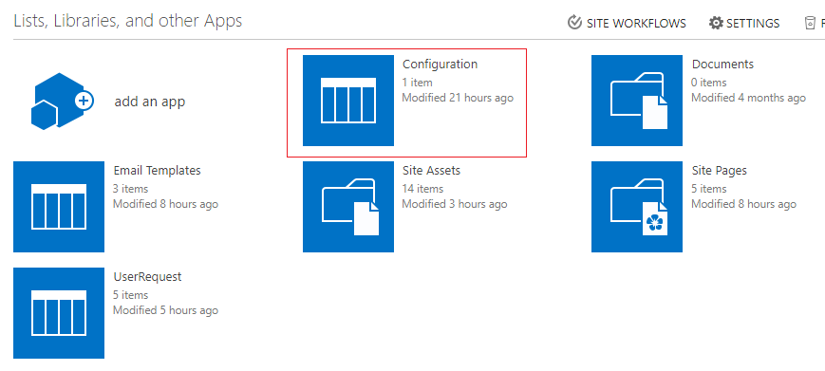
4. Edit the first item with named Default  
   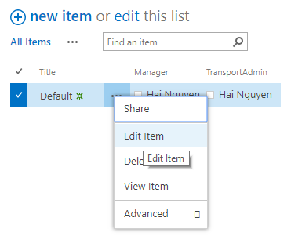
5. This item is configured, so don’t delete it but it can be modified   
   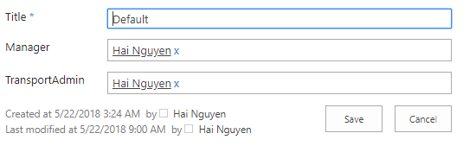
6. Click save to apply

## Email Templates

This list is to store the email content when workflow send the email.

1. Open the site
2. Go to Site Contents
3. Open the list named Email Templates  
   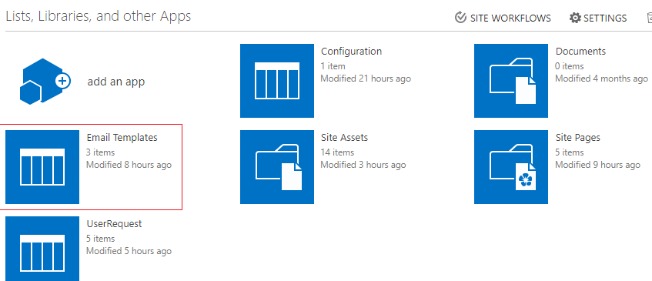
4. This list is pre-configured with 3 items  
   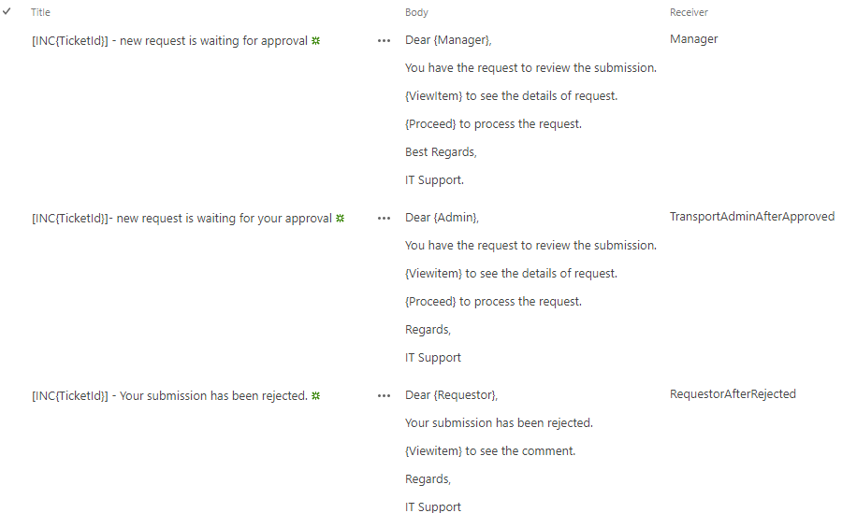
5. With reciver will identify the step of process
   1. Receiver is Manager. This email will send to Manager after user create the new request.
   2. Receiver is TransportAdminAfterApproved. After Manager approved the request, an email will send to Transport Admin.
   3. Receiver is RequestorAfterRejected. After Manager rejected the request, an email will send back to requestor.
6. There are some variables in the email template. It will be replaced automatically.
   1. {TicketId}: will be replaced by request id.
   2. {Requestor} will be replaced by Requestor Name
   3. {Admin} will be replaced by Transport Admin name
   4. {Viewitem} will be replaced by item link to view the details
   5. {Proceed} will be replaced by the approve/reject link

## Create a request

1. Open the site
2. In the dashboard, click Add New Request  
   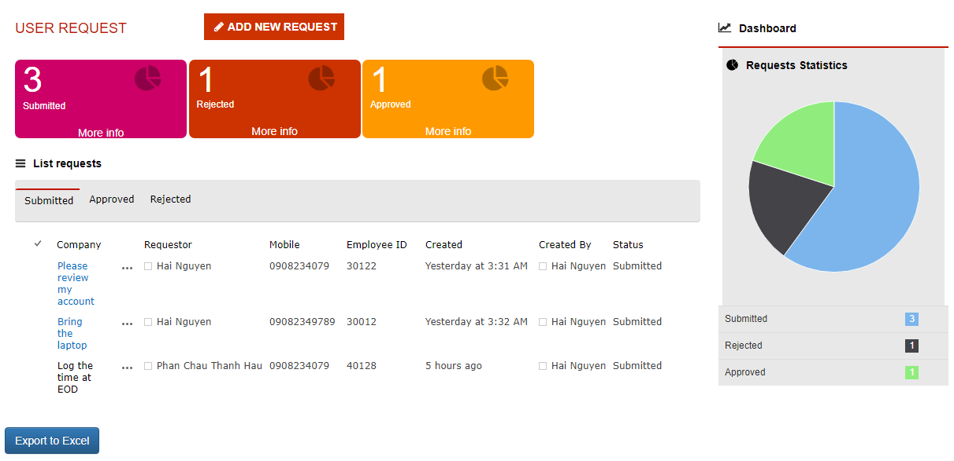
3. The new form is opened   
   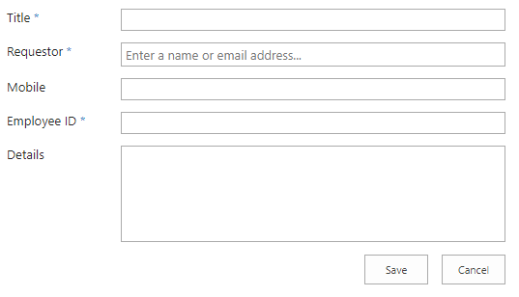
4. Fill in all data in the form. Some fields are required to enter the data. The form is validated when user click on Save button.
5. After click Save button, the page will redirect to another page to process the request.

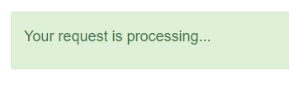

1. After done processing, the page will redirect to home page with dashboard updated.  
   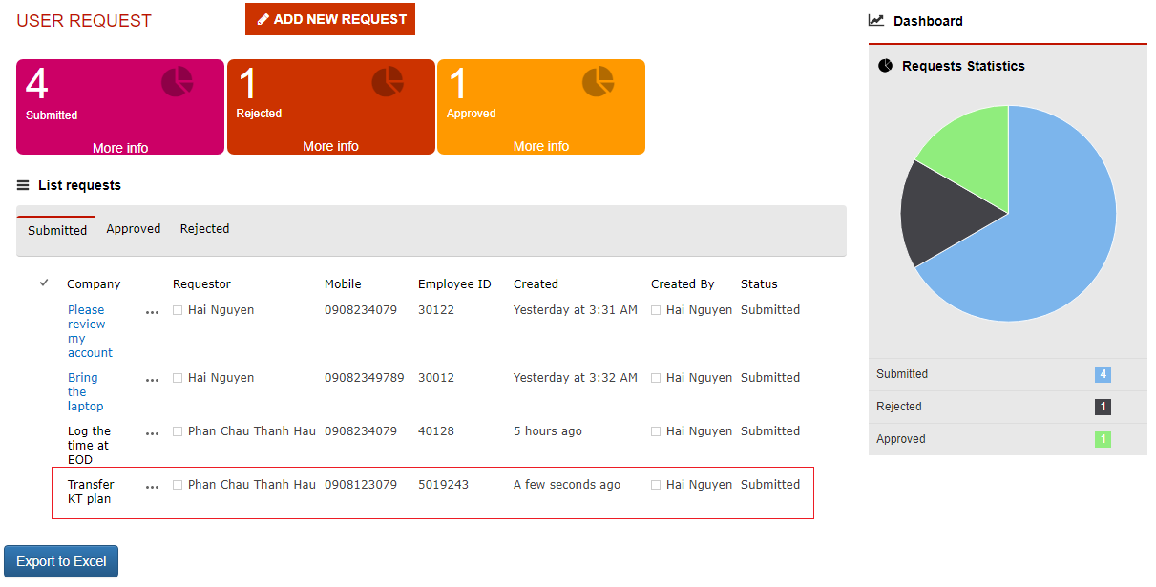
2. The manager will receive the email to approve or reject the request. The email content is stored in the email template and it looks like this.  
   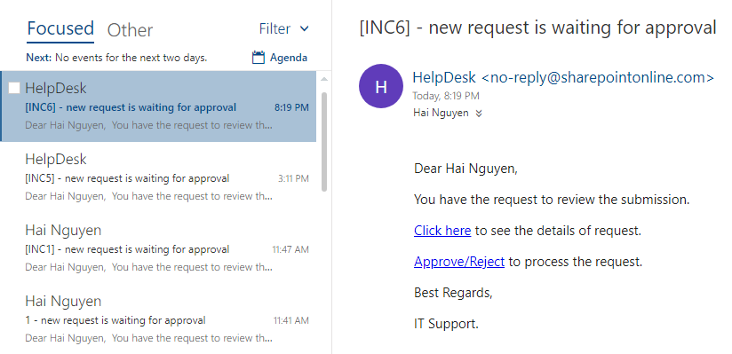
3. Manager can click on the link to open the details of request.  
   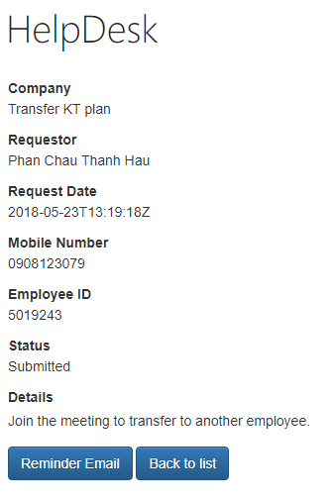
4. At this step, user can click on Reminder Email button to resend the email to Manager. There is no limitation of the number of email reminders. Be aware of spamming email when it sends a lot of email to Manager. Or cluck on the button Back to list to return the home page.
5. Manager also can click on the Approve/Reject to open the control to process the request.  
   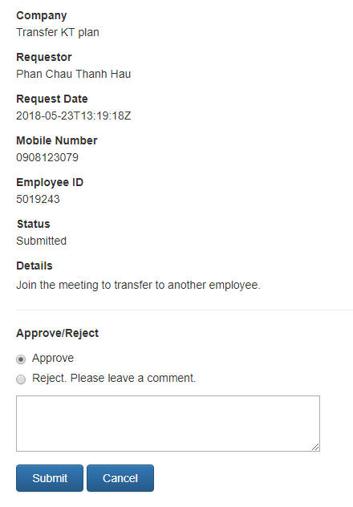
6. If Approve option is selcted, the comment box is optional to enter. If Reject option is selected, the comment box is required to enter. This is to explain why the request is rejected by manager. If the request is approved, there is an email to send to Transport Admin and otherwise there is an email to send back to requestor.
7. The email content to Transport Admin looks like this

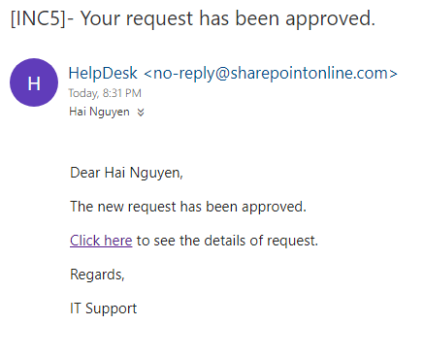

1. The email content if request is rejected.  
   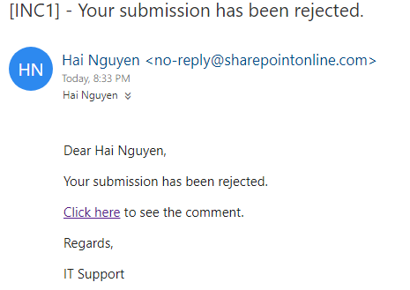

## Sorting & Filtering

On the dashboard, we design the list with 3 tabs: Submitted, Approved and Rejected.

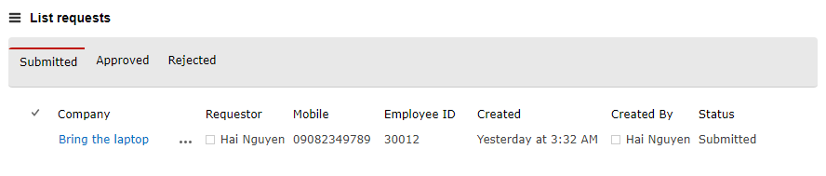

To sort or filter data, user can click on the header of the list and click on the context menu with the option

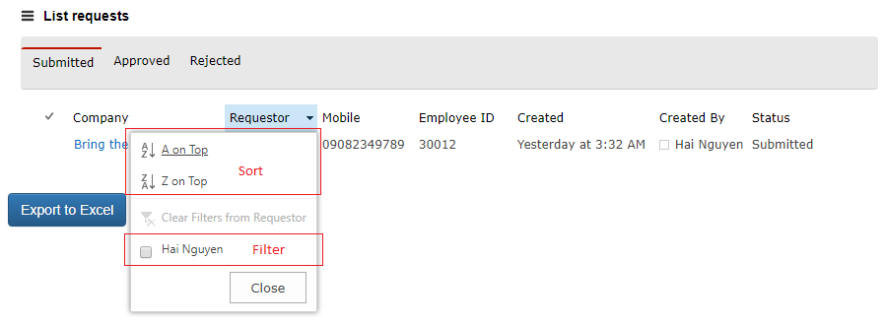

## Search

The search is implemented with OOTB feature. User can search by enter the keyword into textbox and sharepoint system will show the result

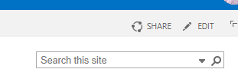

Enter the sample keyword

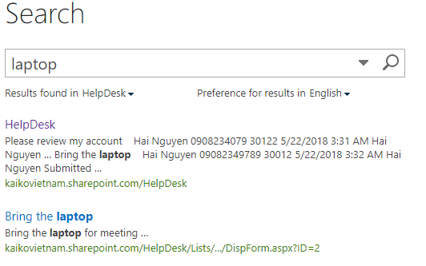  
  
Export to Excel

The button works with activated tab. If the tab Approved is selected, the Export to excel button will get all items with status = Approved and save as excel file.